**Project#1 Proposal**

## **Problem statement:**

We want to increase the number of sign-ups for the women tech womenyes (WTWY) gala.

## **Preliminary results:**

The solution that we came up with is to find the top crowded stations to deploy street teams through out the MTA stations. We will take into consideration the exits number in rush hours assuming that the potential that people will stop and sign up will increase.

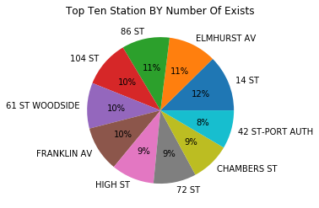

Also, We are excluding the stations that are near the airport to reduce the chance of getting tourists to sign up.

## **Milestones:**

* 1 SCP, 1 Station, Last Week of May.
* All SCP, All Station, Last Week of May.
* All SCP, All Station, Multiple Week (Last Two Weeks Of May And The First Week Of June).

## **What else we could do:**

We could utilize street team resources for example street team#1 will take sign-ups for stationA because it’s crowded in the morning. If there is another station near stationA and more crowded in the evening team#1 should be transferred to take signups from stationB.

## **Conclusion:**

By analyzing New York subway data, we will provide the stations where street teams should be deployed.

**Team members: Meaad, Tarfah, Lama, Dalia, Njoud**